University of Canberra
Faculty of Science and Technology

Software Technology 2
(7170)
Week 12 Tutorial & Computer Lab
Phase 2: Graphs, Heaps and Dynamic Programming with PyGame

Learning Objectives
- Review graph basics: vertices, edges, and representations (adjacency list).
- Implement BFS and DFS algorithms on a graph.
- Visualize graph traversal processes step-by-step in PyGame.
- Learn binary heap data structure and properties (min-heap).
- Implement heap insert and extract-min operations.
- Simulate event scheduling using a priority queue visualized in PyGame.

Task 3_1: Graph Representations & Traversals (BFS and DFS) Visualization

Objectives
- Review graph basics: vertices, edges, and representations (adjacency list).
- Implement BFS and DFS algorithms on a graph.
- Visualize graph traversal processes step-by-step in PyGame.

Key Concepts
- Graph as adjacency list/dictionary.
- BFS: queue-based level-order traversal.
- DFS: stack or recursion-based traversal.
- Visualization of nodes and edges highlighting visit order.

Class Activity (task_3_1.py)
- Review graph basics: vertices, edges, and representations (adjacency list).
- Implement BFS and DFS algorithms on a graph.
- Visualize graph traversal processes step-by-step in PyGame.
#== task_3_1.py==
import pygame
import sys
import collections

pygame.init()

WIDTH, HEIGHT = 600, 400
screen = pygame.display.set_mode((WIDTH, HEIGHT))
FONT = pygame.font.SysFont(None, 24)
clock = pygame.time.Clock()

# Graph nodes positioned manually
nodes_pos = {
'A': (100, 100),
'B': (250, 60),
'C': (250, 200),
'D': (400, 100),
'E': (500, 150),
'F': (400, 300)
}

graph = {
'A': ['B', 'C'],
'B': ['A', 'D', 'E'],
'C': ['A', 'F'],
'D': ['B'],
'E': ['B', 'F'],
'F': ['C', 'E']
}

def draw_graph(visited=set(), frontier=set(), current=None):
screen.fill((240, 240, 240))

# Draw edges
for node, neighbors in graph.items():
x1, y1 = nodes_pos[node]
for n in neighbors:
x2, y2 = nodes_pos[n]
pygame.draw.line(screen, (0, 0, 0), (x1, y1), (x2, y2), 2)

# Draw nodes
for node, (x, y) in nodes_pos.items():
color = (200, 200, 200)
if node in visited:
color = (100, 200, 100)
if node in frontier:
color = (255, 200, 100)
if node == current:
color = (255, 100, 100)

pygame.draw.circle(screen, color, (x, y), 25)
text = FONT.render(node, True, (0, 0, 0))
text_rect = text.get_rect(center=(x, y))
screen.blit(text, text_rect)
pygame.display.flip()

def bfs(start):
visited = set()
queue = collections.deque([start])

while queue:
current = queue.popleft()
visited.add(current)

draw_graph(visited=visited, frontier=set(queue), current=current)
pygame.time.wait(700)

for event in pygame.event.get():
if event.type == pygame.QUIT:
pygame.quit()
sys.exit()

for neighbor in graph[current]:
if neighbor not in visited and neighbor not in queue:
queue.append(neighbor)

def main():
draw_graph()
pygame.time.wait(1000)
bfs('A')
pygame.time.wait(2000)
pygame.quit()

if __name__ == "__main__":
main()

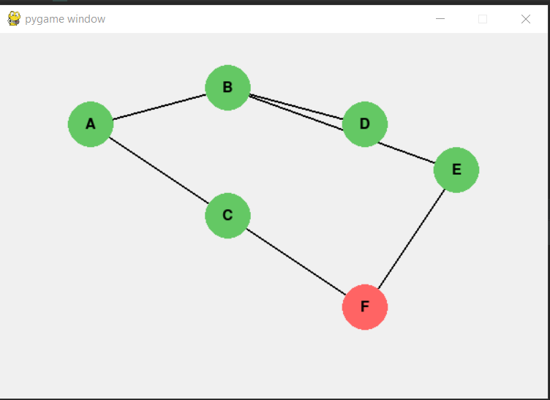

Task 3_1 Challenge Activity (to submit):
Modify Task_3_1.py to:
- Implement DFS visualization with similar node/edge highlighting.
- Add functionality to allow users to click on nodes as start points.
- Add a display of traversal order in text on the screen.

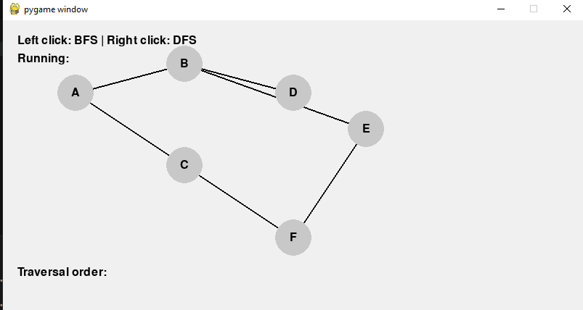

Left click on c
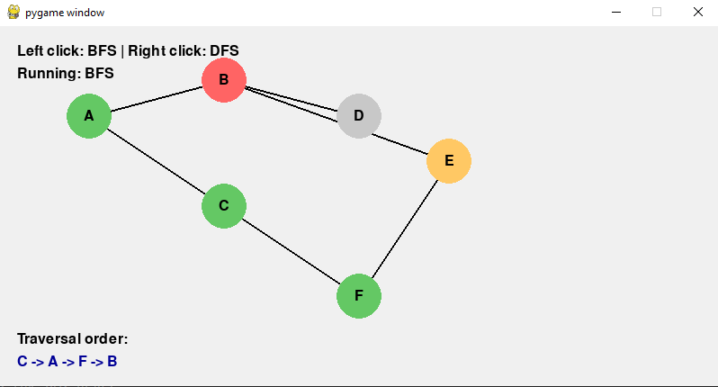

Right click on e
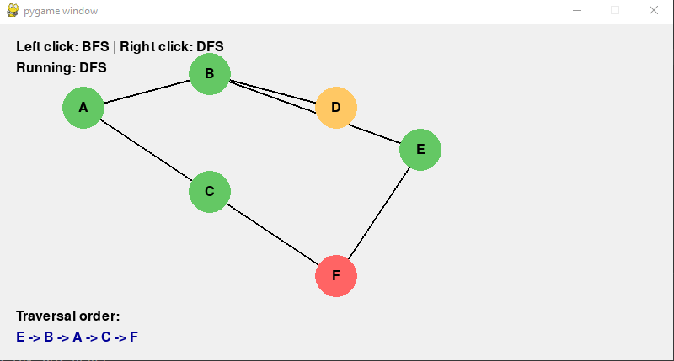

Task 3_2: Heaps and Priority Queues -Implementation and Event Simulation Visualization
Objectives
- Learn binary heap data structure and properties (min-heap).
- Implement heap insert and extract-min operations.
- Simulate event scheduling using a priority queue visualized in PyGame.
Key Concepts
- Binary heap as array-based tree.
- Heapify up/down for maintaining heap property.
- Use heap to order events by priority/time.
- Visualization of heap as tree and array.
Class Activities: Task_3_2.py
- Insert random numbers into heap with animations showing swaps.
- Visualize extract-min removing and heap restructuring.
- Simulate events popping from priority queue by time and display event info.
Challenge Task: Modify Task_3_2.py (assessed as part of Assignment 2-Group Project)
- Implement a priority queue event simulator with events having
- Visualize the heap and show upcoming events.
- Simulate event processing by popping the earliest event and displaying its description on screen.

#Task_3_2.py
import pygame
import sys
import random
import math

pygame.init()

WIDTH, HEIGHT = 600, 400
screen = pygame.display.set_mode((WIDTH, HEIGHT))
FONT = pygame.font.SysFont(None, 24)
clock = pygame.time.Clock()

heap = [] # min-heap implemented as list

def draw_heap(heap, highlight_indices=[]):
screen.fill((255, 255, 255))
if not heap:
text = FONT.render("Heap is empty", True, (0, 0, 0))
screen.blit(text, (WIDTH // 2 - 60, HEIGHT // 2))
pygame.display.flip()
return

levels = int(math.log2(len(heap))) + 1
max_nodes = 2 ** levels - 1
node_positions = []

for i in range(len(heap)):
level = int(math.floor(math.log2(i + 1)))
index_in_level = i - (2 ** level - 1)
gap = WIDTH // (2 ** level + 1)
x = gap * (index_in_level + 1)
y = 60 + level * 70
node_positions.append((x, y))

# Draw edges
for i in range(len(heap)):
left = 2 * i + 1
right = 2 * i + 2
if left < len(heap):
pygame.draw.line(screen, (0, 0, 0), node_positions[i], node_positions[left], 2)
if right < len(heap):
pygame.draw.line(screen, (0, 0, 0), node_positions[i], node_positions[right], 2)

# Draw nodes
for i, val in enumerate(heap):
color = (100, 200, 250)
if i in highlight_indices:
color = (255, 100, 100)
pygame.draw.circle(screen, color, node_positions[i], 20)
text = FONT.render(str(val), True, (0, 0, 0))
text_rect = text.get_rect(center=node_positions[i])
screen.blit(text, text_rect)

pygame.display.flip()

def heapify_up(heap, index):
while index > 0:
parent = (index - 1) // 2
if heap[parent] > heap[index]:
heap[parent], heap[index] = heap[index], heap[parent]
draw_heap(heap, [parent, index])
pygame.time.wait(400)
index = parent
else:
break

def heapify_down(heap, index):
n = len(heap)
while True:
left = 2 * index + 1
right = 2 * index + 2
smallest = index
if left < n and heap[left] < heap[smallest]:
smallest = left
if right < n and heap[right] < heap[smallest]:
smallest = right
if smallest != index:
heap[index], heap[smallest] = heap[smallest], heap[index]
draw_heap(heap, [index, smallest])
pygame.time.wait(400)
index = smallest
else:
break

def insert(heap, val):
heap.append(val)
draw_heap(heap, [len(heap) - 1])
pygame.time.wait(300)
heapify_up(heap, len(heap) - 1)

def extract_min(heap):
if len(heap) == 0:
return None
root = heap[0]
heap[0] = heap[-1]
heap.pop()
draw_heap(heap, [0])
pygame.time.wait(300)
heapify_down(heap, 0)
return root

def main():
running = True

insertions = [random.randint(1, 100) for _ in range(10)]
idx = 0

while running:
screen.fill((255, 255, 255))

for event in pygame.event.get():
if event.type == pygame.QUIT:
running = False

if idx < len(insertions):
insert(heap, insertions[idx])
idx += 1
pygame.time.wait(600)
else:
pygame.time.wait(1000)
if heap:
extracted = extract_min(heap)
else:
running = False

draw_heap(heap)
clock.tick(30)

pygame.time.wait(2000)
pygame.quit()

if __name__ == "__main__":
main()

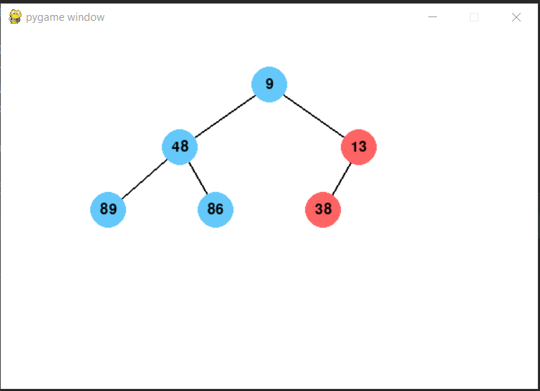
- Task_3_ 2 Challenge Activity (To submit):
Modify task_3_2.py to:
- Implement a priority queue event simulator with events having time and description.
- Visualize the heap and show upcoming events.
- Simulate event processing by popping the earliest event and displaying its description on screen.

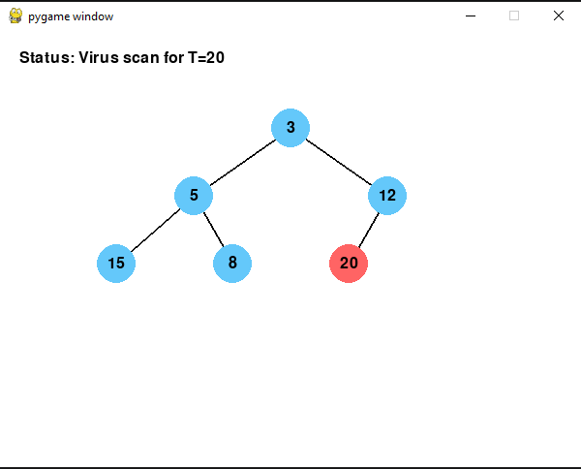

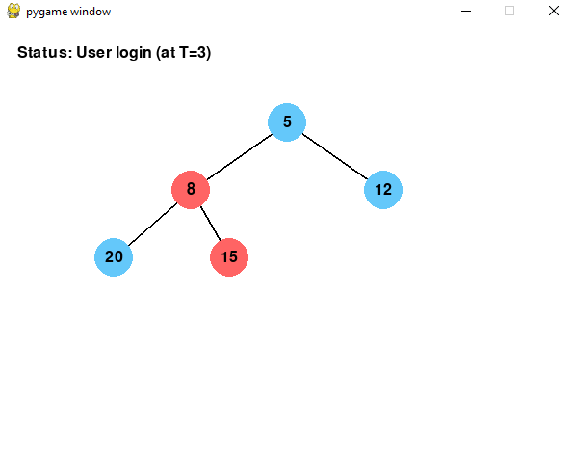

Task 3_3: Dynamic Programming -Grid Path Counting Problem Visualization Objectives
- Learn the principle of dynamic programming (DP): solving subproblems and storing results.
- Solve a classic DP problem: count number of unique paths from top-left to bottom-right of a grid.
- Visualize DP table filling and path counting step-by-step.
Key Concepts
- Overlapping subproblems, memoization or tabulation.
- Bottom-up DP approach in a 2D grid.
- Visual mapping of DP states on grid cells.
Class Activities: Task_3_3.py
- Grid displayed with highlighted cells showing partial sums of paths.
- Animate filling DP table row-by-row or cell-by-cell.
Challenge Task: Modify Task_3_3.py (assessed as part of Assignment 2-Group Project)
• Modify the grid to include obstacles where paths cannot pass. Visualize updates on DP table accordingly.
• Add a feature to reconstruct and draw one valid path from start to finish after computing the DP table.
• Implement a DP solution to a different problem (e.g., coin change) with visualization.

#==task_3_3.py==
import pygame
import sys

pygame.init()

WIDTH, HEIGHT = 600, 600
ROWS, COLS = 6, 6
CELL_SIZE = WIDTH // COLS
screen = pygame.display.set_mode((WIDTH, HEIGHT))
FONT = pygame.font.SysFont(None, 30)
clock = pygame.time.Clock()

def draw_grid(dp, highlight=None):
screen.fill((255, 255, 255))
for r in range(ROWS):
for c in range(COLS):
rect = pygame.Rect(c * CELL_SIZE, r * CELL_SIZE, CELL_SIZE, CELL_SIZE)
color = (200, 200, 200)
if highlight == (r, c):
color = (255, 180, 180)
pygame.draw.rect(screen, color, rect)
pygame.draw.rect(screen, (0, 0, 0), rect, 1)

val = dp[r][c]
if val is not None:
text = FONT.render(str(val), True, (0, 0, 0))
text_rect = text.get_rect(center=rect.center)
screen.blit(text, text_rect)
pygame.display.flip()

def count_paths():
dp = [[None] * COLS for _ in range(ROWS)]
for r in range(ROWS):
for c in range(COLS):
if r == 0 and c == 0:
dp[r][c] = 1
else:
up = dp[r - 1][c] if r > 0 else 0
left = dp[r][c - 1] if c > 0 else 0
dp[r][c] = up + left
draw_grid(dp, (r, c))
for event in pygame.event.get():
if event.type == pygame.QUIT:
pygame.quit()
sys.exit()
pygame.time.wait(300)
return dp[ROWS - 1][COLS - 1]

def main():
draw_grid([[None] * COLS for _ in range(ROWS)])
pygame.time.wait(1000)
total_paths = count_paths()
print(f"Total unique paths: {total_paths}")
pygame.time.wait(3000)
pygame.quit()

if __name__ == "__main__":
main()

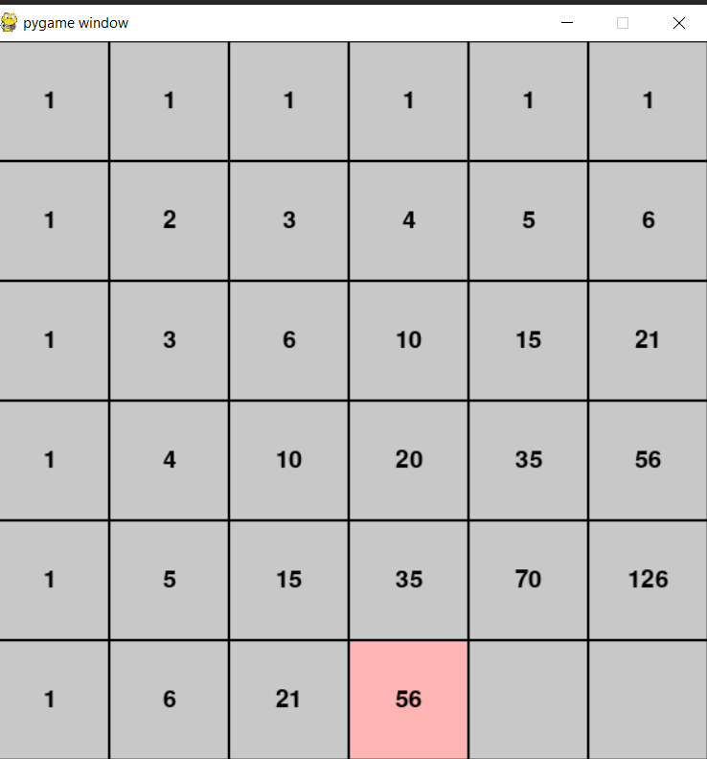

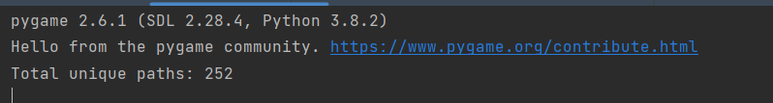
- Task_3_ 3 Challenge Activity (To submit):
Modify task_3_3.py to:
• Modify the grid to include obstacles where paths cannot pass. Visualize updates on DP table accordingly.
• Add a feature to reconstruct and draw one valid path from start to finish after computing the DP table.
• Implement a DP solution to a different problem (e.g., coin change) with visualization.
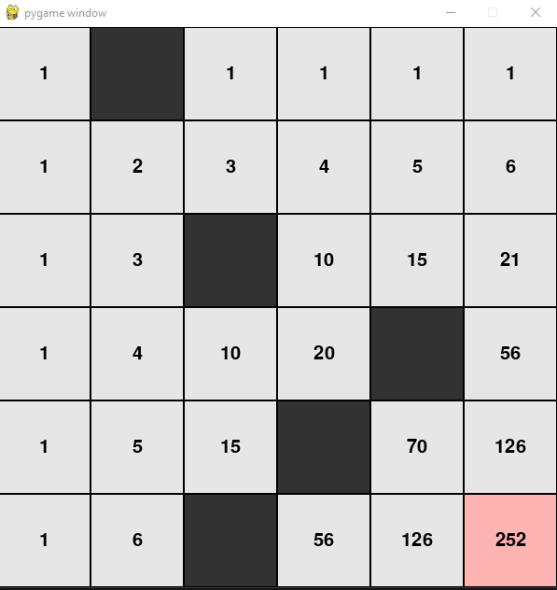

Submission requirements from Week 12 tutorial tasks for Assignment 2-Group Project

Phase 3  Tasks | Tasks for learning (not assessed) | Tasks for Submission (assessed
3.1 | Graph Representations & Traversals (BFS and DFS) Visualization  - Review graph basics: vertices, edges, and representations (adjacency list).  - Implement BFS and DFS algorithms on a graph.  - Visualize graph traversal processes step-by-step in PyGame. | - Implement DFS visualization with similar node/edge highlighting.  - Add functionality to allow user to click on nodes as start points.  - Add a display of traversal order in text on the screen.
3.2 | Heaps and Priority Queues - Implementation and Event Simulation Visualization | - Implement a priority queue event simulator with events having  - Visualize the heap and show upcoming events.  - Simulate event processing by popping the earliest event and displaying its description on screen.
3.3 | Dynamic Programming -Grid Path Counting Problem Visualization Objectives  - Grid displayed with highlighted cells showing partial sums of paths.  - Animate filling DP table row-by-row or cell-by-cell. | • Modify the grid to include obstacles where paths cannot pass. Visualize updates on DP table accordingly.  • Add a feature to reconstruct and draw one valid path from start to finish after computing the DP table.  • Implement a DP solution to a different problem (e.g., coin change) with visualization.

